The 1st. phase of the new factory for the production of electronic components for household appliances for emz Hanauer Romania s.r.l. in Valea Terovei Industrial area in Reșita in Caraș-Severin County is completed

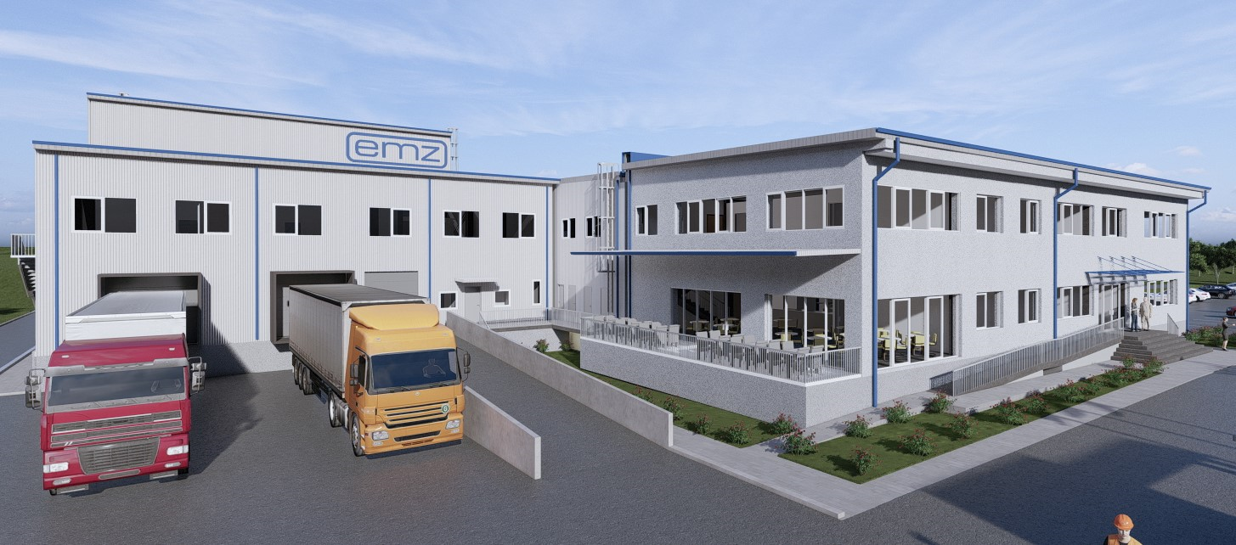

From vision to reality!!!

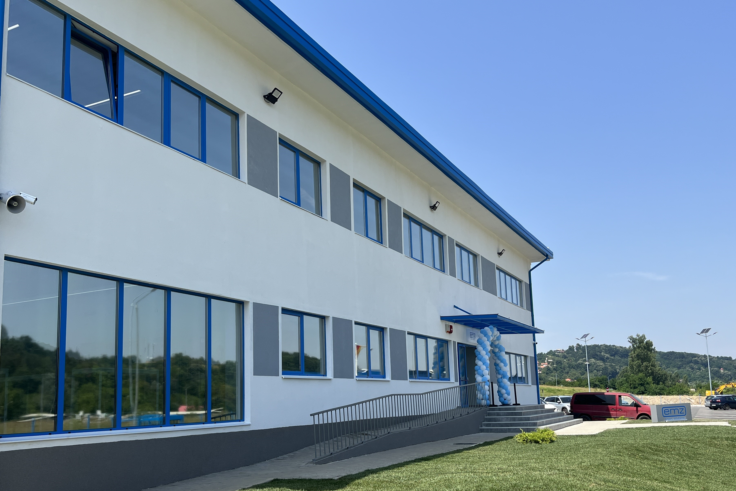

Beneficiary:
 emz Hanauer Romania s.r.l.
Project partners:

Project manager and general designer:



In cooperation with:

Concept design Arthur O´Looney Design s.r.l.

General design Tekton Engineers and Partners s.r.l.

Structural & architectural design Neo Structural Engineering

MEP design WPS wireprojects

Site Management S.C. GRC-Company

Site Master (diriginte de santier) PROMaes EXPERT



General Contractor: ICCO Facility Management



Project history:

- In 2021 emz Hanauer GmbH acquired a plot of land for the construction of a household appliance components factory, which should become their fifth production site beside Germany, Chech Republic, Mexico and China.
- In September 2021 Fine Building Consultants s.r.l., together with its partner Arthur O´Looney design s.r.l. drew a masterplan for a 22.000 sq m factory which shall be developed in several phases.
- For the building permit design of phase 1 Fine Building Consultants s.r.l. cooperated with Tekton Engineers & Partners, Neo Grup and WPS wireprojects in 2022, followed by the detailed execution design.
- In July 2022 the permit was issued and the construction could start. ICCOFM Brasov won a tender competition and agreed with emz Hanauer to construct the project as General Contractor for roundabout 8 million Euro in 8 months.
- GRC-Company and PROMaes Expert were partners of Fine Building Consultants for the site management.

Key data:

- Administrative building P+1E – building C1; incl. kitchen and canteen
- Storage hall P+1E – building C2
- Production hall P+1E – building C3
- Appendices:
- Compressor chamber building C4;
- Pump room building C5;
- Gate cabin building C6;
- Water reservoir for hydrants;
- Platform access and car parking; 58 parking spaces including disabled persons

Built-up area 5,783.89 sq m, of which 4,494.88 sq m on the ground floor and 1,289.01 sq m on the first floor



